The Transferable Tiger.
It’s Tommy this and Tommy that, and Tommy needs a job!

In 1794, so legend or martial myth has it, at the Battle of Bokstel, the Duke of Wellington found a soldier lying wounded in the mud. “It’s all right, sir, all in a day’s work,” the injured Private Tommy Atkins told the Iron Duke.

Having left the military, hopefully in better shape than Tommy Atkins, a Tiger’s priority will probably be to achieve ‘a day’s work’. So what skills do you have and what roles do they fit? What have others done before you?

5 Reasons to Employ a Veteran Tiger:

- Veterans have valuable attitudes and are adaptable;
- Veterans make highly efficient employees;
- Employing a Veteran is good for business and society;
- Veterans fill skills gaps;
- Veterans have strong technical skills and unique qualities.

Where do veterans work?

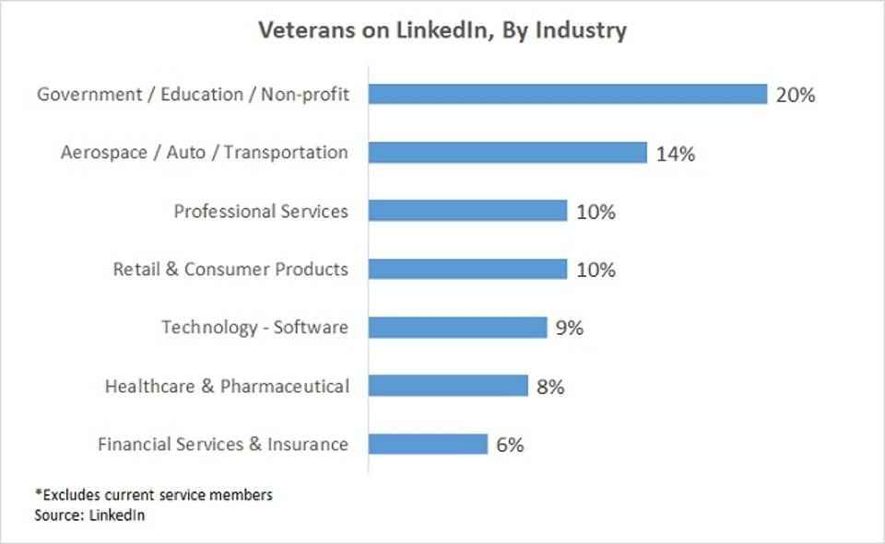

The chart above comes from some analysis on LinkedIn, into where Veterans have found employment. It might give you some ideas. Also, there are over 1,500 employers across the UK that have pledged their support to the Armed Forces community. Whether serving or a Veteran, there is a multitude of employment sites dedicated to Armed Forces and able to offer professional, impartial and practical advice on all aspects of transition and work.

What are your General Skills?

You may think of yourself as having limited or specialist skills. However, you probably also have most or all of the following:

- Management / Leadership;
- Decision-making or analytical skills;
- Desire, Dedication, Discipline, and Determination;
- Team-building Skills;
- Mission-focussed and a will do attitude.

These are all characteristics that employers seek, but they can be taken for granted by servicemen and women. In today’s workplace, the following skills are particularly important:
- Problem Solving
Given the closeness and camaraderie experienced in the regiment, Tigers are good at creating quick rapport, identifying needs and solving them - Veterans are experienced in rapid problem-solving as providing solutions quickly and under pressure is something just about every Tiger is familiar with. Also, they are structured and have important organisational skills.
- Tech-Savvy
Nowadays the military relies heavily upon state-of-the-art equipment and systems so most Armed Forces personnel are familiar with technology. That “know-how” and attention to detail provides a familiarity with technology and could lead to a position for a Veteran managing or being part of a team focused on creating new technical products, fault finding, maintenance and servicing.

Veterans represent a unique, diverse and high-performing source of talent. Many companies are missing out on this great talent–pool due to a lack of knowledge about the military or misconceptions based on negative stereotypes. Often, unless a business is part of the military supply chain, or facing a specific skills shortage prompting them to look more widely for talent, they are unlikely to have considered the ex-military community as a potential source of talent. This feels like a missed opportunity, particularly at a time when companies are finding it hard to recruit.

Service in the Armed Forces fosters leadership, organisational skills, resilience and many other unique qualities which are a great asset to the private sector. Don’t be shy about selling yourself!

