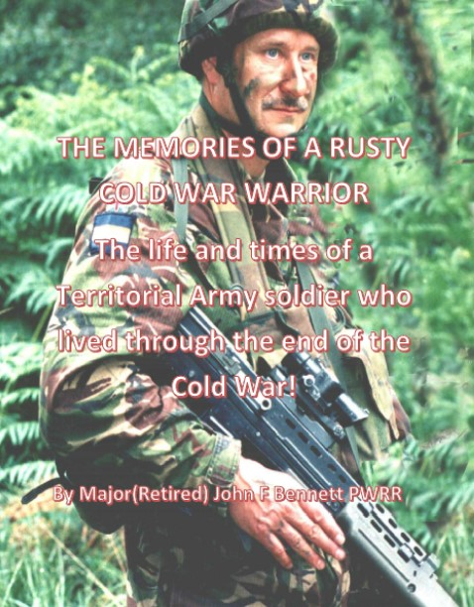
The Memories of a rusty Cold War Warrior is now available
This paperback book charts the progress of a naïve motor mechanic joining the TA to get a driving licence, through to the Company Commander and Battalion second in command on the cusp of another regular deployment to Iraq.
27 years of service with the usual lumps and bumps on route.
Foreword by Colonel JP Ladd TD, Colonel, Army Reserve (Infantry) and afterword by Sir Julian Brazier TD former Captain in 10 PARA (V) and MP For Canterbury until 2016.

A small tantaliser ……. I recalled the time a very good friend of mine suggested we went fishing, we were in a tactical position nearby and the food was getting a little boring. We were doing a week of range packages and, very unusually, we were in a tactical hide rather than in barracks. Jack tied 6 thunder flashes together and then to a brick. He struck the fuses and threw the bomb into the river. After a few moments there are a phzzz and that was that. Jack was disappointed and vowed to increase the explosion.
Two days later we went fishing again; unbelievably Jack had hidden a grenade in his kit and again tied it to a brick, pulled the pin and threw it into the water. A huge plume of water erupted and as the water settled we saw…………..
Proceeds of the sale go to the PWRR/Queen’s regimental museum in Dover castle. The cost will be £10 plus postage. This is a limited production of 250 books, if you are interested in a copy please either give me a call on 01227 709840 or drop me an email to johnbennett@pwrr.co.uk I am also on facebook.

